1. Run nslookup to obtain the IP address of a Web server in Asia. What is the IP
address of that server?
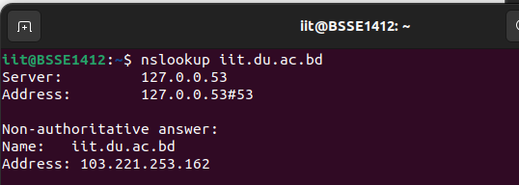
Ans: 103.221.253.162

2. Run nslookup to determine the authoritative DNS servers for a university in
Europe.
Ans:
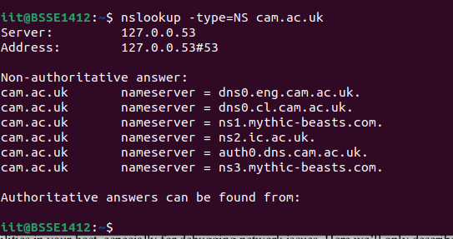

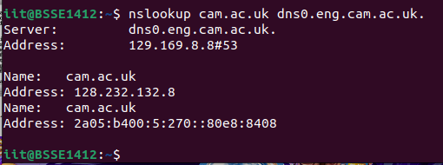

3. Run nslookup so that one of the DNS servers obtained in Question 2 is queried for
the mail servers for Yahoo! mail. What is its IP address?
Ans: 103.221.252.2#53

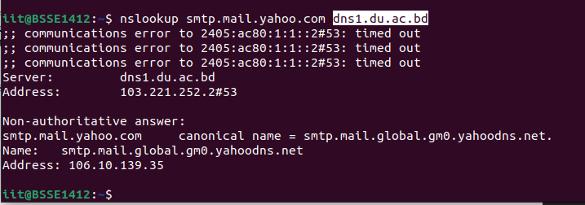
nmcli dev show | grep DNS

